Technology Summary
Overall Device
SannTek has developed a novel point of care diagnostic device for use at home or in clinical settings. The device is composed of three different components:
- Cartridge: The cartridge contains the sensor and all the reagents required to run a test. These cartridges are single use only, and the user need to use a new one every time they run a test.
- Analyzer: The analyzer contains the electronics and hardware required to run a test. The cartridge is inserted into the analyzer in order to run a test.
- The App: The app connects to the analyzer via Bluetooth and lets of the user control and analyzer. It also lets the user view historical data.
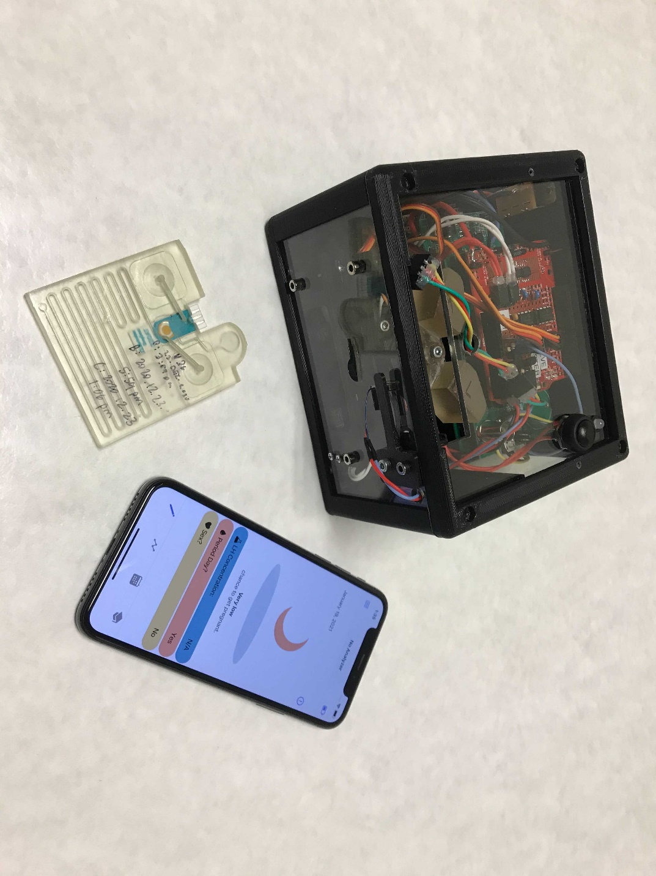
Analyzer
App
Cartridge
(Noah, do you want the actual device or renders?)
This device is currently configured to detect luteinizing hormone (LH) in urine to help individuals identify the LH spike that accompanies the window of peak fertility. In order to use the device, the user follows the steps below:
- Step 1: The user urinates into a cup to collect a urine sample.
- Step 2: The user inserts the urine sampler on the cartridge into the cup to intake a sample.
- Step 3: The user inserts the cartridge into the analyzer.
- Step 4: The user uses presses a button on the analyzer to start the test. The test takes 5 minutes.
- Step 5: After 5 minutes, the app alerts the user that the test is complete. The user enters the app and sees if they are ovulating.
- Step 6: The user disposes of the cartridge in a common garbage
The Sensor
The sensor used in the SannTek device is a sandwich electrochemical sensor. It is composed of three components:
- An electrode
- A capture receptor against LH immobilized on the electrode
- A labelled receptor molecule, also against LH.
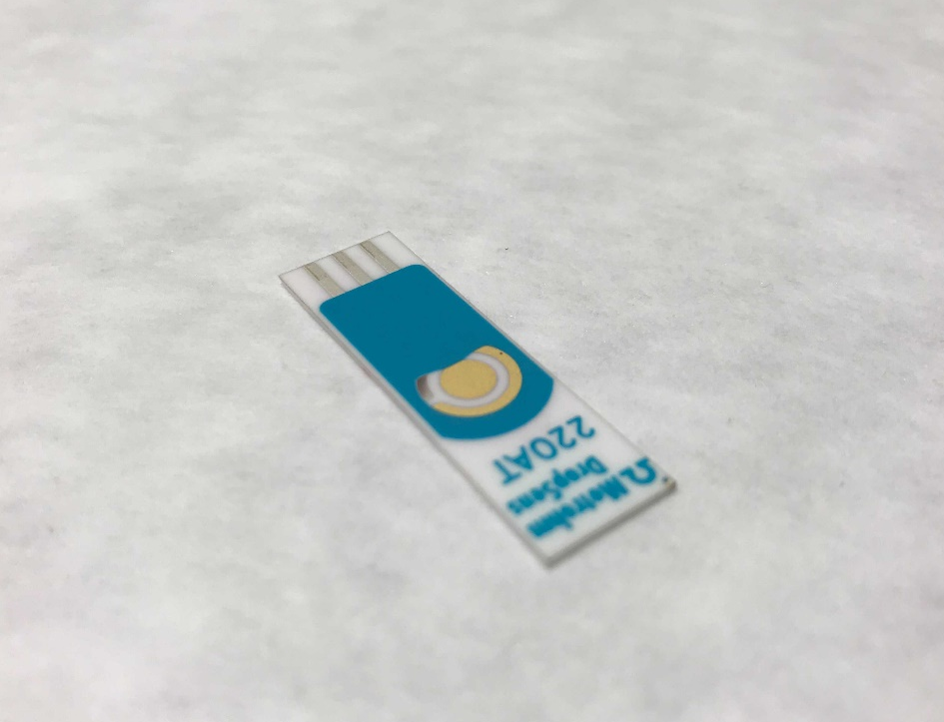
The sensor functions as follows:
- Step 1: The sample is added to the surface of the electrode. Any LH in the sample binds to the receptors.
- Step 2: The second labelled receptor is added to the surface of the electrode. If LH is bound, the second receptor also binds.
- Step 3: A voltage is applied to the electrode. If the labelled receptor is bound, current will be generated (indicating LH is present). If the labelled receptor is absent, not current will be generated.
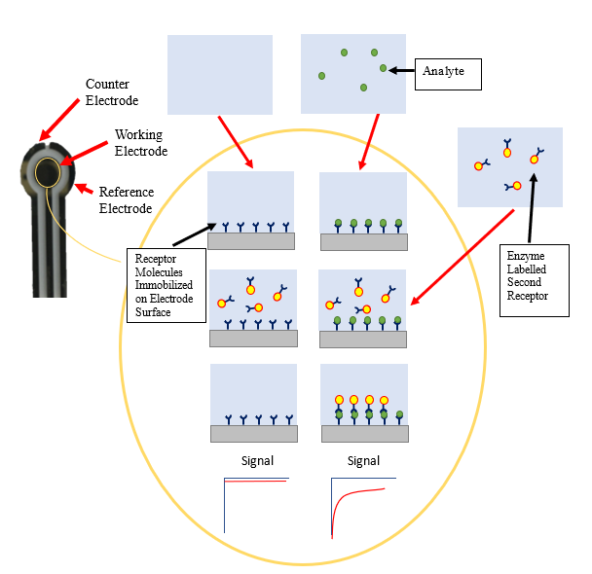
While the current system is designed to detect LH, it can be reconfigured to detect any analyte with two simple changes. By switching the capture receptor and the labelled receptor for reagents against the new target (for instance, capture receptors against COVID antibodies instead of LH), the sensor can be re-configured for a new target. The rest of the sensor, cartridge, and analyzer remain completely unchanged. This platform has already been modified to detect THC, testosterone, and COVID IgGs.
The Cartridge
SannTek uses a novel injection molded cartridge to automate the sensor. This cartridge allows the sensor to be used by untrained personnel outside of a laboratory environment. The cartridge is designed to be driven entirely by gravity and simple drive hardware, making it incredibly cost effective (less than $1 at scale).
